DARTFISH USERS GUIDE

- Switch on the laptop
- Set up the camera and attach the camera to the laptop with the firewire cable.
- Launch the Dartfish pro suite programme and the following screen appears

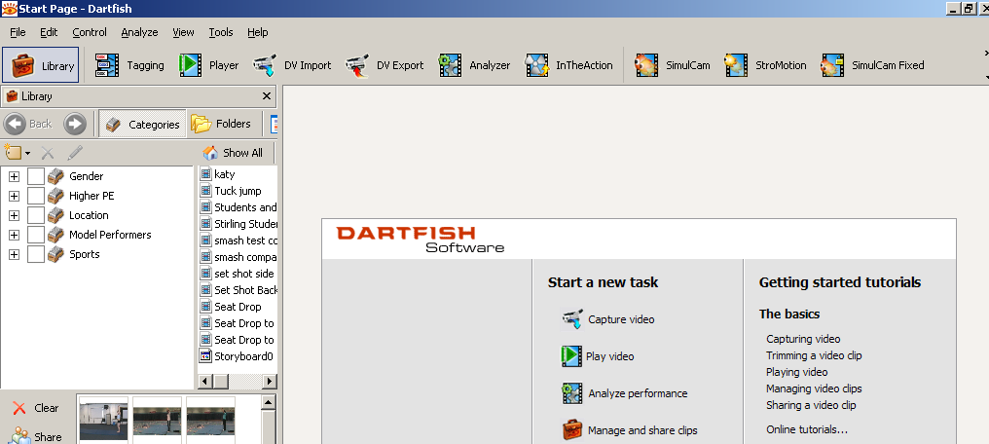

- If you want to capture a new piece of action click on the In the action icon and the following screen will appear.

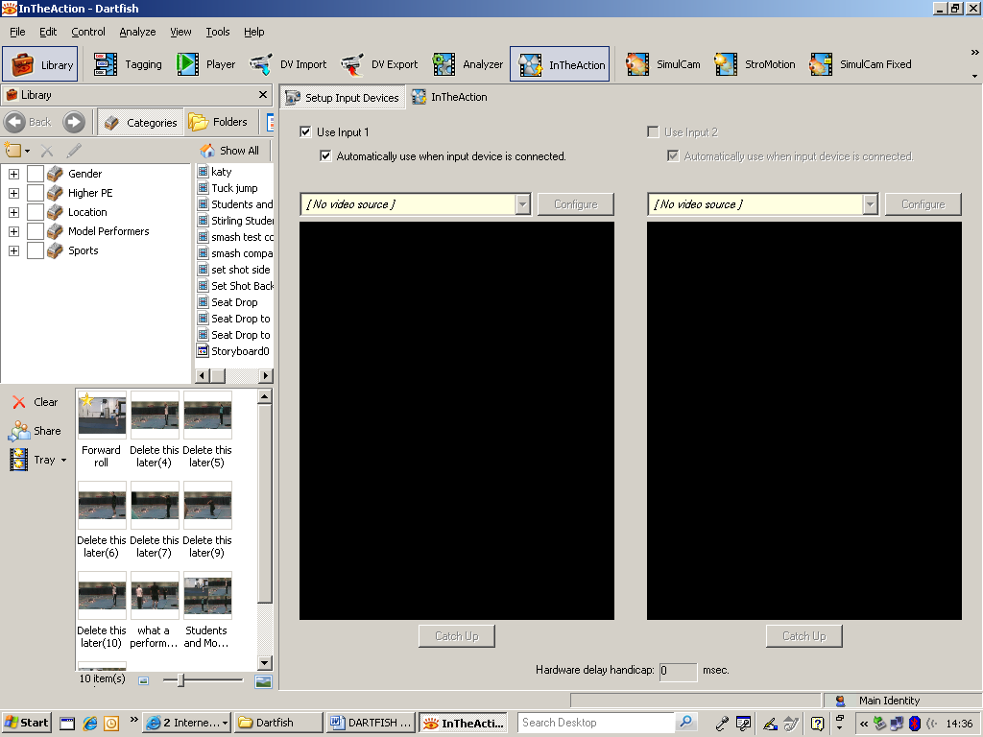

If this screen appears with black panes as above there is no video source click on this drop down menu and select the camera you are using. Then click on the in the action tab the screen on the next page will appear
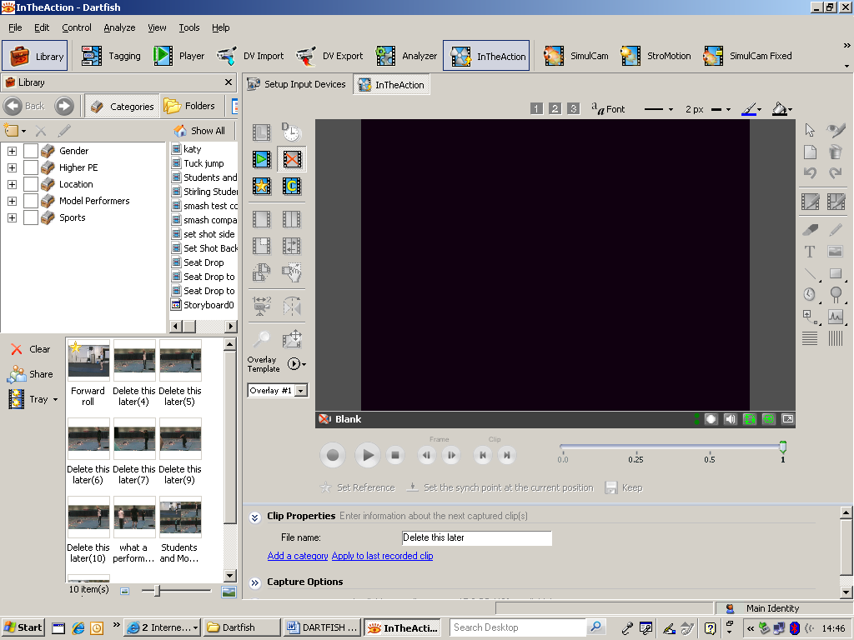

- To capture the action you have 2 options you can click on the record button on the computer screen or you can use the remote control

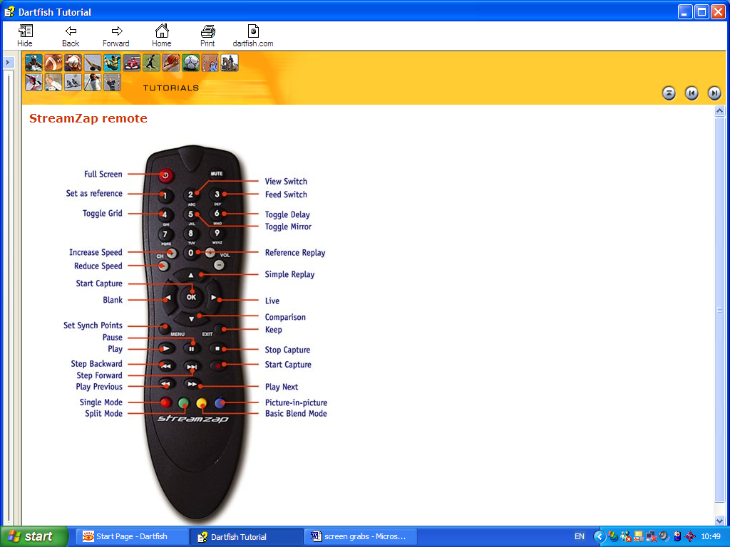

When the action is captured it will play back automatically in a continuous loop. You can adjust the speed pause or stop the clip using the playback controls located on the remote or at the bottom of the application.

- Label your clip and set capture location in the clip properties. If you want to adjust the length of time of the capture and the pre roll click on the capture options button and the following window will appear. Then make sure the in the action tab is selected.

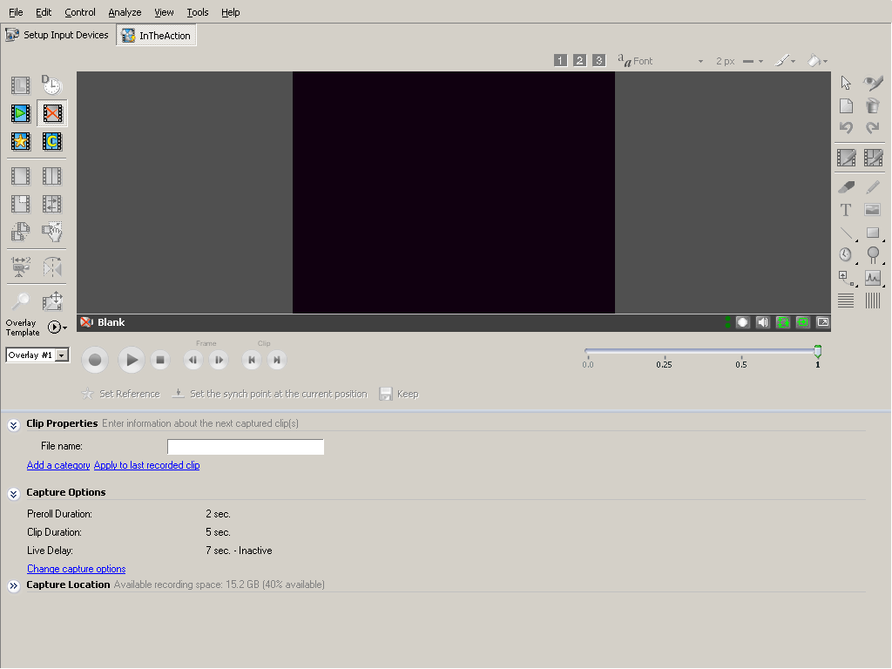

- If you wish to make a comparison to a clip that you have already captured then you will have to set the clip as a reference. Then click on the comparison on the remote control or the button on the screen

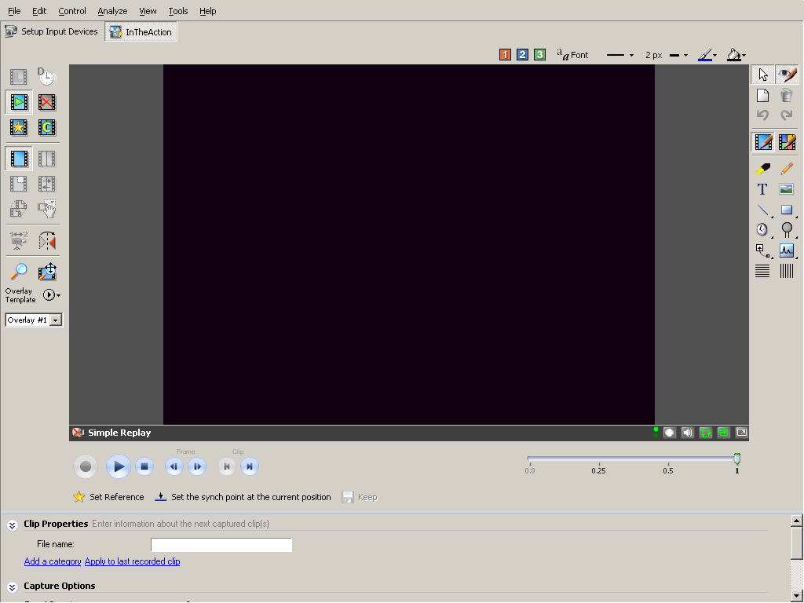

- The drawing tools to enhance the video feedback and add drawings and annotations are all located here
- If you just want to play a clip then you can either use in the action or the player. Select the clip that you wish double click on and it will start to play.

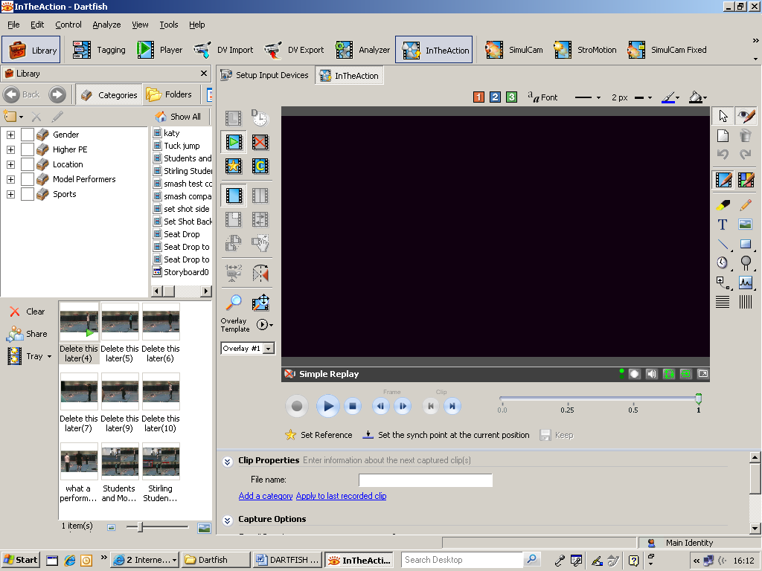

- If you wish to show the laptop images through the digital projector you need to connect the laptop to the projector by the cable which goes into the port on the rear of the laptop. Switch on the projector it will take about 30 seconds for the image to be projected. If there is no image being projected you will have to hold down the function key (located on the bottom row of the keyboard with Fn written on it) and press the appropriate function key normally the F4 key but changes from laptop to laptop (located on the top row) It will take a few seconds to adjust. If there is still no image repeat the process. The laptop screen may go blank if this happens just repeat the process. All that is happening is the laptop is going through the different viewing options. The image can be laptop only, projector and laptop or projector only.

